INTRODUCTION
The AFPM research grant was introduced in 2008 with the objective of promoting primary care research in Malaysia. Many of the existing research grants hosted by large organisations target experienced researchers with high expectations of research outcomes. To help smaller projects by novice primary care researchers, the AFPM have decided to create this research grant to help fund projects conducted by members of AFPM.

RESEARCH GRANT
AFPM Primary Care Research Grant amount is RM20,000 per year with a maximum of RM40,000 per project while ATFM Student Grant is maximum RM4,000 per project.

THE REVIEW COMMITTEE
The review committee shall be appointed by the chairperson of Malaysian Primary Care Research Group (MPCRG), an interest group under the auspices of AFPM.

ELIGIBILITY CRITERIA
The applicant must be an active member of the AFPM.
- For any grant application that is RM10,000 and above, the applicant must be AFPM Life Member.

PROCESS OF APPLICATION
The research proposal must be submitted to the review committee through the secretariat before the deadline. The application form must be sent to the secretariat via email (mpcrg@afpm.org.my). No hardcopy submission is required. The proposal should contain sufficient details to justify your grant application. The outcome of the application will be notified to the applicant within 2 months (timeline may vary). However, the grant will be released after the ethical approval of the research project by the respective ethics committee. The principal investigator of the research project is responsible for forwarding the evidence of the approval such as letter of approval from the ethics committee to the secretariat.

Please enclose the following to complete your application:
- Participant information
- Consent form
- Questionnaire or data collection form (whichever is relevant)

ETHICS APPROVAL
The review committee may help to advise on where to obtain the ethics approval if necessary.

REPORTS
- Interim Progress Report
Must be submitted by 31st December every year (regardless timing of grant award or approval)

- Final Report
- Submit final report one year after the last interim report (by 31st December) in any submitted, accepted or published abstract or manuscript.
- Submit final budget report (attached along)
PUBLICATION
Awardees are encouraged to publish their findings in the AFPM official journal, Malaysian Family Physicians. However, the principal investigator has the rights to the final decision of publication.

Awardees MUST acknowledge AFPM in any form of output: We suggest the statement below:
“Funding for this study was provided by the Academy of Family Physicians of Malaysia (AFPM/ADMIN/xx/xxxx). The funding body had no role in the study's design, collection, analysis or interpretation of data, nor in writing the manuscript.”

OUTPUT

Fund | Researcher | Student
RM4000 and below |  | Oral or poster presentation to any conference (face-to-face or online)  OR  Publication of at least SCOPUS
RM 4000 - 10,000 | Oral or poster presentation to any conference (face-to-face or online)  OR  Publication of at least SCOPUS
More RM 10,000 | Publication in either  - SCOPUS  - ISI

SECRETARIAT
Malaysian Primary Care Research Group (MPCRG)
Unit 1-5, Level 1 Hive 4 Taman Teknologi Mranti,
Jalan Innovasi 1 Lebuhraya Puchong-Sungai Besi
Bukit Jalil, 57000 Kuala Lumpur.

Telephone: 603 - 8993 9176 / 603 - 8993 9177
Fax: 603 - 8993 9187
Email: mpcrg@afpm.org.my
Website: www.afpm.org.my/mpcrg

PROJECT INFORMATION
Title of Project
*Please fill in UPPERCASE
Principal Investigator
*For ATFM Research Module, mentor should not be the Principal Investigator, but co-investigator
Institution/Place of Practice
*Including address
Email
*Make sure email is valid
Telephone/Fax

CO- INVESTIGATOR
No | Name | Institution/Place of Practice
1
2
3
4
5
6

INVESTIGATOR’S AGREEMENT, MENTOR’S APPROVAL
*This section is ONLY for ATFM Trainee’s Project – Research Module*

INVESTIGATOR’S AGREEMENT
We understood the above-mentioned proposed research and agree to participate as investigators and being responsible conducting the research.
NAMES | 1.
 | 2.
 | 3.
 | 4.
 | 5.
 | 6.
INTAKE
GROUP
DATE

MENTOR’S APPROVAL
I have viewed and agreed to supervise the above-named investigators to conduct the above titled research.
NAME OF MENTOR
SIGNATURE
DATE

- Background information (outline the literature review, current development and rationale for your study) *Insert the relevant reference list at the end of this section. Limit this section to two (2) pages.

- Objectives (state your general objective(s) & specific objective(s) here clearly)

- Methods (outline the type of study design, sampling, intervention (if any), data collection, data analysis & any relevant to your project’s methods)

- Expected outcomes (if any) & the significance of the findings.

- Budget (outline the potential cost and expenditure for the project in details)
*Example: salaries, stationeries, travel, equipment, token to participants, others

Please refer to COVERED & NON-COVERED table as below according to grant category:
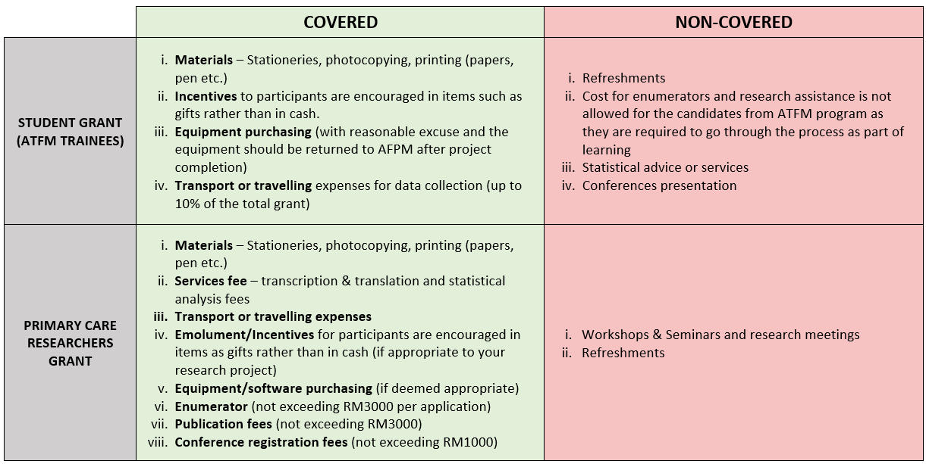

*Please fill in your budget with proper categories, item, unit per cost and amount.
CATEGORY | ITEM | UNIT x COST/UNIT | AMOUNT (RM)
Stationeries  [Example] | Pens  Pencils | 50 x RM1.50  50 x RM1.00 | 125.00
TOTAL AMOUNT

- Project milestone (outline the proposed schedule (Gantt chart) for different stages of research activity)
*Use Grant Chatt below to outline schedule
 |  | Year: |  |  |  |  |  |  |  |  |  |  |  | Year: |  |  |  |  |  |  |  |  |  |  |  | Year:
 | Stages | J | F | M | A | M | J | J | A | S | O | N | D | J | F | M | A | M | J | J | A | S | O | N | D | J | F | M | A | M | J | J | A | S | O | N | D
1
2
3
4
5
6
7
8
9
10
11
12

Other Fund Provider(s)
*List other sources of funding for this project if any

Institution | Amount Awarded (RM)
Organization X  [Example] | 2000.00
TOTAL AMOUNT

AFPM Grant Application
TOTAL AMOUNT OF APPLICATION (RM) | :

DECLARATION OF APPLICANT

I, Principal Investigator, as written on this form, have read, and understood the guidelines for AFPM Research Grant Application. The above information is true to the best of my knowledge. Provision of false information may result in withdrawal of the funds.

------------------------------------
Name:
Date:

